**PROJECT REPORT TEMPLATE**

1. ***INTRODUCTION***
   1. ***Overview***

The world has changed as a consequence of the increasing use of smartphones, which have improved communication, connected people, and revolutionized many different businesses.

With its main product, the iPhone, capturing markets around the world, Apple Inc. In order to shed light on important factors like market penetration, customer preferences, economic ramifications, and societal changes, this research report will perform a data-driven investigation of the impact of the iPhone.

**PURPOSE**

Tableau project help you to connect with several data sources, analyse data, and visualize it to get superior insights.

It popular Business Analysts Business Analysts frequently use tableau projects to share the processed data with other users throughout the enterprise and engage with the results in real-time.

And crosstabs are useful for performing comparative analysis between specific points of data.

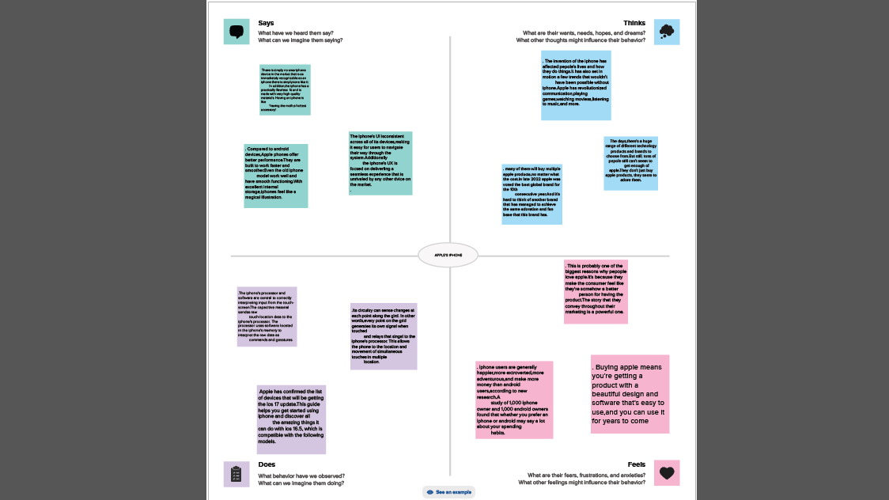

***2.2 Ideation & Brainstorming Map***

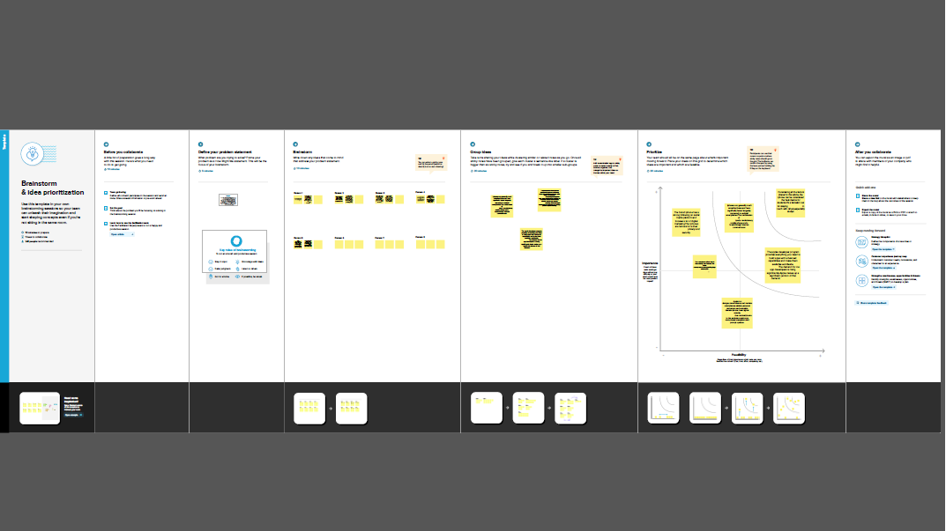

***3 RESULT***

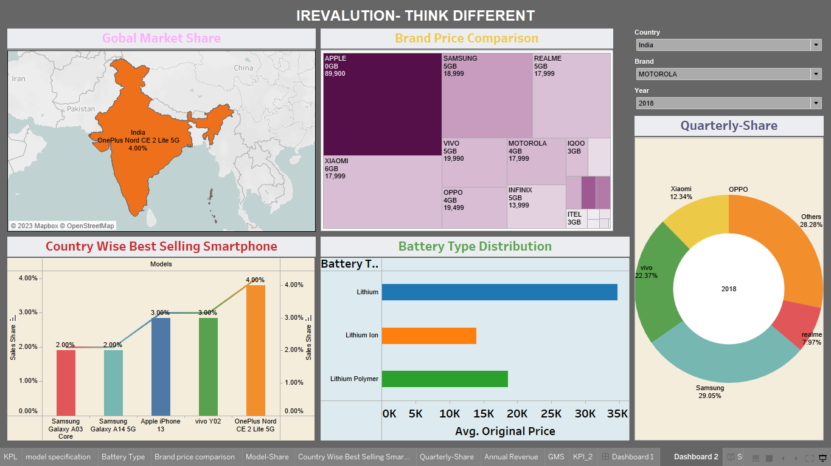



***4 ADVANTAGES & DISADVANTAGES***

***Advantages:***

There iPhone is an ideal phone to use if you own other Apple products, such as Mac computers, iPad and iPods. With Apple’s free iCloud service, the iPhone shares data, music, photos and contacts with all your other Apple products. It’s an added convenience that takes the hassle out of transferring data between products.

There are several other advantages that iPhone users enjoy. The iPhone 5 contains an enhanced Retina display with 362 pixels per inch for a bright, crisp image.

The Apple Ecosystem can be a blessing yet a curse at the same time. Apple products are designed to allow the user a smoother experience with all of its other products such as the Apple Watch or iPad.

***Disadvantage***:

One disadvantage of an iPhone is that once you purchase it, there is no going back. You’ll be trapped into Apple’s Ecosystem as long as you use the devices and care about compatibility.

Apple increases the price of iPhones every year. IPhone is currently one of the most expensive smartphones out there usually due to its constantly updated physical appearance and tweaks made by engineers within the phone.

The iPhone batteries are non-removable, which means that users cannot replace them.

***5 APPICATIONS***

Apple Application support is a software component developed by Apple Inc. It is primarily used to ensure compatibility and provide necessary frameworks for various Apple applications to run smoothly on windows operating systems.

The including all iOS and Android app stores, there are currently 8.93 million apps available in the world. As of 2022, approximately 1.6 MILLION apps were available in Apple’s App store and over 3 million Android.

A software application that runs under iOS, which is the operating system that powers Apple’s mobile.

***6 CONCLUSION***

In conclusion, Apple’s strategic focus on expanding its service sector, continuously evolving its iPhone, and diversifying its range of accessory products has established the company as an unparalleled force in the consumer electronics and technology marketing

***7 FUTURE SCOPE***

The most important part of the iPhone might be everything around it. That’s according to analysts who’ve observed the mobile industry’s general trends and Apple’s strategy. In the short term, we’re likely to see incremental improvements like higher quality cameras and giant displays.

The iOS App Development must keep track of these technological changes to provide a seamless experience for users. Machine Learning, Artificial Intelligence, and Augmented Reality are just a few of the latest technologies on which they can improve their knowledge.